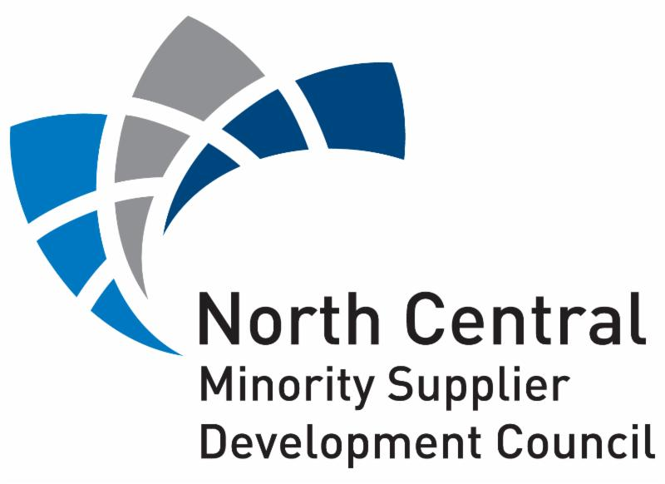
SERVING
Iowa, Minnesota, North Dakota,
South Dakota, Wisconsin

SUBSCRIPTON SERVICES APPLICATION INFORMATION

The North Central Minority Supplier Development Council (NCMSDC) provides additional services to out of region MBEs that have a current Certification with any Affiliated Regional Council of the National Minority Supplier Development Council (NMSDC). Below are the details to obtain Subscription Services with NCMSDC and the benefits associated with this region.

Subscription Services Benefits:
- Subscription Services acknowledgement letter
- Access to the Council’s local Corporate Members
- Communication from Council on upcoming events and opportunities
- Participation in Business Development Webinars
- Inclusion in MBE sourcing pool depending on the product or service requested
- Eligible to participate in NCMSDC programs and events, Sponsor NCMSDC platforms and showcase your business at the annual Business Opportunity Exchange (BOE)

Eligibility:
Must be an active certified MBE within the NMSDC Network, must be in good financial standing with home Affiliate Regional Council at time of Subscription Services request, must be 60 days away from your home Affiliate Regional Council certification expiration date when applying for Subscription Services.

Annual Renewal:
Subscription Services run concurrently with the certification of your home Affiliate Region Council, meaning that any Subscription Services will expire at the same time as your home Affiliate Regional Council certification expiration date. Once you recertify with your home Regional Affiliate Council you are eligible to renew your Subscription Services. Any NMSDC-certified MBE requesting Subscription Services within 60 days of their certification expiring, will be asked to withhold their request until recertification with their home Reginal Affiliate Council is completed.

WHEN SEDING YOUR SUBSCRIPTION SERVICES APPLICATION INCLUDE THE FOLLOWING:
- Current MBE Certification Certificate from your home Affiliate Regional Council

- Capability & Capacity Statement
  - Our Corporate Members ask us to run searches for upcoming sourcing opportunities, Subscription Services MBEs are included in these searches, a Capability & Capacity Statement helps our Corporate Members with their decision-making process regarding
their sourcing needs

- Payment and application return to the NCMSDC:
  - Email completed application, MBE Certificate, and Capability & Capacity Statement to Antronette Mahomes at amahomes@northcentralmsdc.net
  - To pay by credit card, please contact Reehanah Al-Othman at 414-666-8725

SERVING
Iowa, Minnesota, North Dakota,
South Dakota, Wisconsin

SUBSCRIPTON SERVICES APPLICATION

PLEASE PRINT CLEARLY or TYPE IN INFORMATION:

Company Name:

Company Website Address:

Company Physical Address:

Primary Owner’s First and Last Name:

Primary Owner’s Title:

Primary Owner’s Phone #:

Primary Owner’s Email Address:

(If Applicable)
Other Owner’s First and Last Name:

Other Owner’s Title:

Other Owner’s Phone #:

Other Owner’s Email Address:

Current Annual Sales: $_____________________

- Subscription Services Class:
(please select one):

  - Class 1 Class 2 Class 3 Class 4

Fee Category by  Annual Revenue (Millions) | Class 1  < $1.0 M | Class 2  $1.0 – $9.9 M | Class 3  $10.0 - $49.9 M | Class 4  $50.0 M
Subscription Services Fees | $300 | $400 | $500 | $750

SERVING
Iowa, Minnesota, North Dakota,
South Dakota, Wisconsin

SUBSCRIPTON SERVICES APPLICATION (cont.)

Business Structure:
(please select one)

Corporation Limited Liability Corporation or Company

General Partnership Sole Proprietorship

Type of Business:
(please select one)

Broker/Agent Construction Contractor Consultant/Professional

Distributor Manufacturer Manufacturer Rep Service Contractor

Company Size:
- Total # of Fulltime Employees ______ / # of Minority Fulltime Employees ______

- Total # of Part Time Employees ______ / # of Minority Part Time Employees ______

NAICS Codes:
(list all that apply)

Product/Service Description: (please print clearly or type in information)

(a separate document with your Capability & Capacity Statement is still required)

Please Return Both Pages of The Subscription Services Application Along With Your Current Home Affiliate Regional Council MBE Certificate, and Your Capability & Capacity Statement to Antronette Mahomes at amahomes@northcentralmsdc.net

If you have questions regarding Subscription Services with the NCMSDC, please
contact Antronette Mahomes at 612.465.8884.

